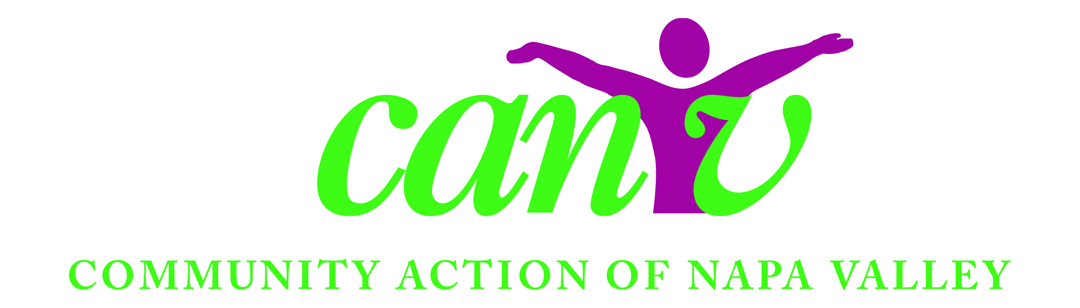

Volunteer Application
Upon completion, please return/mail to
1766 Industrial Way, Napa, CA 94558

NAME: ________________________________________ BIRTHDATE: ____________________

STREET/CITY: _________________________________________________ ZIP: ______________

PHONE: ________________ CELL: ________________ EMAIL: ___________________________

EMERGENCY CONTACT: __________________________________________________________
(Name, phone, relation)

AVAILABILITY: ___________________________________________________________________

LOCATIONS: (Check one or more):

__________ American Canyon __________ Calistoga __________ St. Helena
__________ Angwin __________ Napa __________ Yountville
__________ Berryessa __________ Pope Valley

CATEGORIES: (Check one or more):

__________ Food Handler __________ Clerical __________ Driver

PROGRAMS: (Check one or more):

__________ Brown Bag Brown Bag Site (Optional): _________________

__________ Pantry __________ Warehouse __________ One Time
__________ Friday Free Market __________ Gleaners __________ USDA

Any particular skills you may have? ______________________________________________

Why is volunteering for the Napa Valley Food Bank programs of interest to you?

